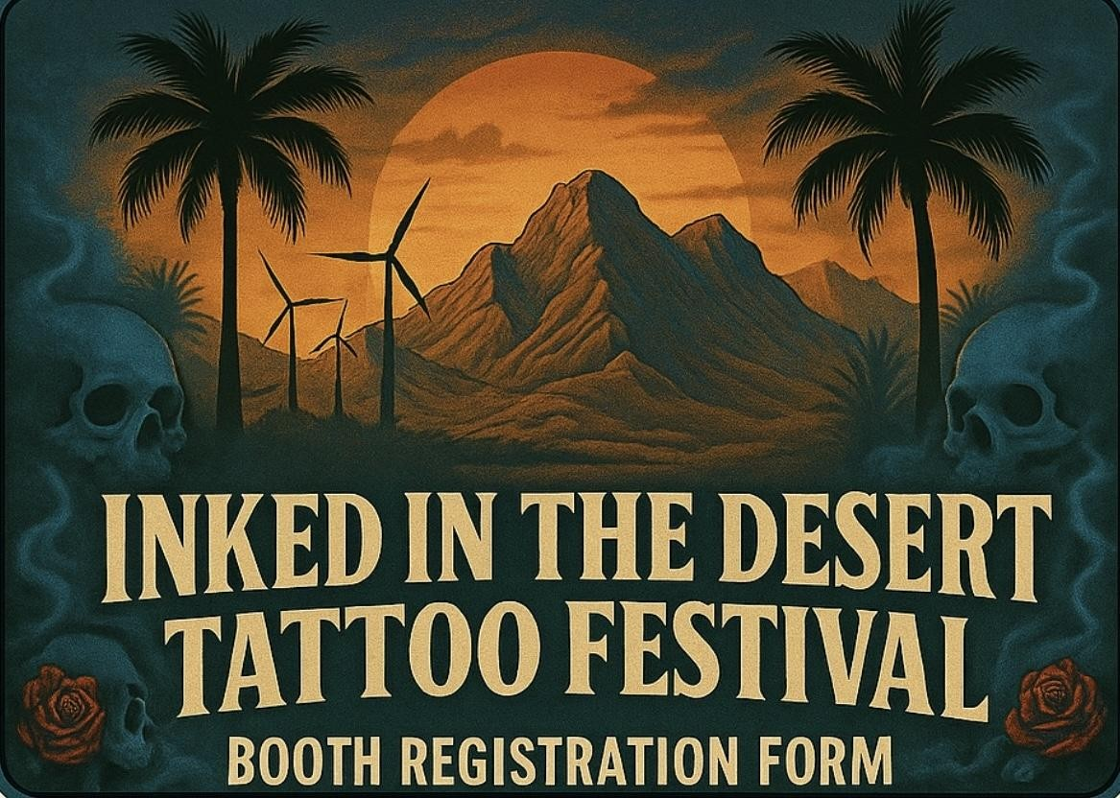
Registration Form & Contract Agreement
Please read contract terms and information in full.

DATE & TIMES
Friday, January 23rd 4:00 pm – 12:00 am
Saturday, January 24th 12:00 pm – 12:00 am Sunday, January 25th 12:00 pm – 7:00 pm

SET-UP INFORMATION
Register At The Information Station
Once Signed In You Will Receive Your Welcome bag

Set-Up begins on Friday, January 23rd at 10:00 am
Ends promptly at 4:00 pm
Please Email 2 Photo’s Per Booth With Your Application for The Website Artist/Body Mod/Vendor Highlight Page.

Booth Registration Information
Tattoo Artist:
- 10’ x 10’ Booth Space
- 2 Vendor Weekend Passes
- 2 Tables
- 4 Chairs
- 1 Roll of Paper Towels (Tattoo Booth)
- 1 Garbage Pail (Tattoo Booth)
- 1 Gallon Distilled Water (Tattoo Booth)
- 1 Sharps Container (Tattoo Booth)
Vendor Booth Includes:
- 10’ x 10’ Booth Space
- 2 Vendor Weekend Passes
- 2 Tables
- 4 Chairs

Booth Reservation Information
- All booths are reserved on a first-come, first-served basis with payment in full.
- Booth numbers will be assigned and emailed with your purchase receipt.
- Request will be honored if your booth preference is available.
- Pricing:
  - Booth: Corner $750
  - Booth: Midline $650
  - Booth: 1 Corner 1 Midline $1250
  - Booth: 2 Midline $1150
  - Booth: 3 Midline $1700
  - Non-Tattoo Vendor (midline booths ONLY) $600
- No refunds
Body Art & Body Mod Practitioner’s agree to operate in accordance with the California Safe Body Art Act, Riverside County Ordinance 907 and all applicable laws governing safe body art practices.
REGISTRATION FORM
Business Name: __________________________________________________________
Address: ________________________________________________________________
Phone Number: __________________________________________________________
Email Address: ___________________________________________________________
Instagram/Facebook/Website: ______________________________________________
- Name:____________________________________________________________
- Name:____________________________________________________________
- Vendor Type__________(1-Tattoo Artist/Studio 2-Piercer/Body Mod 3-Other)

- Accepted forms of payment - Apple Pay, Zelle, Check
- No refunds after booth has been assigned
- Email application to inkedinthedesertfest@gmail.com
- By Signing Below, You Agree That You Have Read the Above & Agree to all the Terms of This Contract.

Signature: _________________________________________ Date: _________________
1. Current Registration. Practitioner must have current Certificate of Registration issued by County of Riverside (or another California LEA). Certificate may be displayed or in a folder. Note: If the certificate is issued by a jurisdiction outside of Riverside, it is valid in Riverside for no more than five consecutive days, or 15 days total, in any one calendar year.
2. Photo Identification. Make available upon request by the inspector.
3. Equipment. Instruments that are not of safe design will not be allowed at the event and may be impounded.
4. Use appropriate personal protective equipment while performing body art procedures. At a minimum this includes the use of gloves.
5. Practitioners shall properly cover or bag their tattoo machine and clip cord when in use and use barrier film or bags for other procedural items.
7. Practitioners shall clean and disinfect client chair, table, and tattoo machine between clients. Acceptable disinfectants are those that are EPA-registered and indicate on the label that they are effective against Hepatitis B.
